**SVKM’s NMIMS**

**School of Technology Management & Engineering, Chandigarh**

A.Y. 2023 - 24

**Course: Database Management Systems**

**Project Report**

|  |  |  |
| --- | --- | --- |
| Program | BTi | |
| Semester | Sem 8 | |
| Name of the Project: | Dock Management System | |
|  | | |
| Details of Project Members |  |  |
| Batch | Roll No. | Name |
| B2 | C037 | Armaan Shah |
| B2 | C059 | Thanush Raju Kaneshan |
|  |  |  |
| Date of Submission: | | |

**Contribution of each project Members:**

|  |  |  |
| --- | --- | --- |
| Roll No. | Name: | Contribution |
| C037 | Armaan Shah | Relation Diagram, Created Database Inserted the values, Update, Aggregate, Views |
| C059 | Thanush Raju Kaneshan | ER Diagram, Created the tables, Alter, Select, Order by, Join |

**Github link of your project: https://github.com/Thnjs/DBMS-Project**

**Note:**

1. Create a readme file if you have multiple files
2. All files must be properly named (Example:R004_DBMSProject)
3. Submit all relevant files of your work ( Report, all SQL files, Any other files)
4. **Plagiarism is highly discouraged (Your report will be checked for plagiarism)**

**Rubrics for the Project evaluation:**

|  |  |
| --- | --- |
| First phase of evaluation:  Innovative Ideas (5 Marks)  Design and Partial implementation (5 Marks) | 10 marks |
| Final phase of evaluation  Implementation, presentation and viva, Self-Learning and Learning Beyond classroom | 10 marks |

**Project Report**

**Dock Management System**

**by**

**Armaan Shah, Roll number: C037**

**Thanush Raju Kaneshan, Roll number: C059**

**Course: DBMS**

**AY: 2023-24**

**Table of Contents**

|  |  |  |
| --- | --- | --- |
| **Sr no.** | **Topic** | **Page no.** |
| **1** | Storyline | 4 |
| **2** | Components of Database Design | 4 |
| **3** | Entity Relationship Diagram | 5 |
| **4** | Relational Model | 6 |
| **5** | Normalization | 6 |
| **6** | SQL Queries | 7 |
| **7** | Learning from the Project | 14 |
| **8** | Project Demonstration |  |
| **9** | Self-learning beyond classroom |  |
| **10** | Learning from the project |  |
| **8** | Challenges faced |  |
| **9** | Conclusion |  |

**I. Storyline**

This section should describe the requirements for the chosen database topic. Form a storyline and describe in detail.

The SQL queries describe a bustling seaport. The Import and Export tables track cargo, while the Cargo_ship and Type_of_cargo tables detail the ships and their cargo. The Cruise_ship, Crew, and Passenger tables manage passenger ships and their occupants. The Onsite_worker table records port workers, linked to the Berths_docks table for their assigned berth. The Weather_conditions table tracks the port’s weather. Several alterations are made to the database schema to better reflect the port’s operations.

**II. Components of Database Design**

Describe all entities along with their attributes here. Also, mention the primary keys for each entity.

Describe all relationships among various entities. Also, specify the cardinality and participation for all relationships.

Entities are:

1. Import

2. Export

3. Types of Cargo

4. Type of ship

5. Details of passenger

6. Details of crew

7. Cruise ship

8. Onsite workers

9. Weather condition

10. Berth/docks

Import:

1. Source

2. Type of Cargo

3. Owner

4. Supervisor (person in charge of unloading cargo)

5. Company

Export:

1. Destination

2. Type of cargo

3. Supervisor (person in charge of uploading)

4. Receiver

5. Company

Cargo ship:

1. Ship no.

2. Type of Cargo

3. Source

4. Destination

5. Cargo unloaded

6. Cargo loaded

7. Entry date

8. Exit date

Type of cargo:

1. Ship no.

2. Live (type of organism)

3. Fragile (bool)

4. Size

5. Weight

Cruise ship:

1. Ship no.

2. Captain Name

3. Source

4. destination

5. Occupancy

6. No. Of life boats

7. Entry date

8. Exit date

Crew:

1. Ship no.

2. Name of crew

3. Job description of crew

4. Contact of crew

5. Blood type

Passenger:

1. Name of passenger

2. Ship no.

3. Contact

4. Blood type

5. Room number/type/floor

6. Disabilities

Onsite worker:

1. Name

2. Employee_id

3. Role

4. Bloodtype

5. Contact

6. Schedule

Weather Conditions Table:

1. Date

2. Temperature

3. WindSpeed

4. Visibility

5. Precipitation

Berths/docks Table

1. BerthID

2. Length

3. Width

4. Status

5. Depth

6. Equipment available

**III. Entity Relationship Diagram**

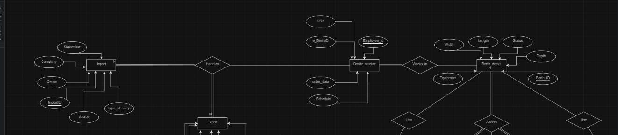

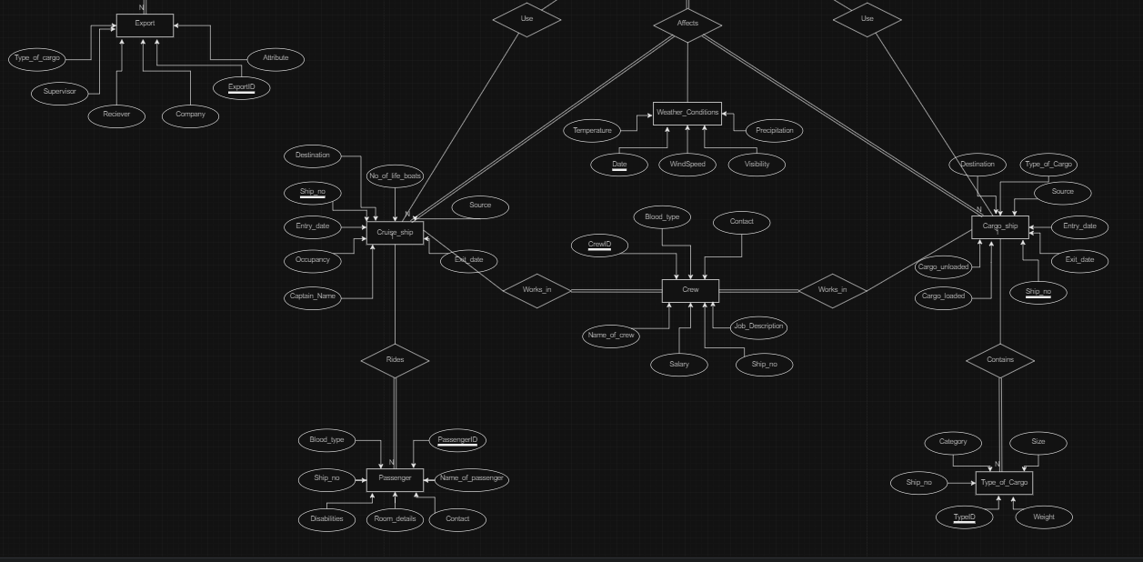

**IV. Relational Model**

Convert the ER diagram to the relational model using the concepts learned in the class.

List the various tables obtained.

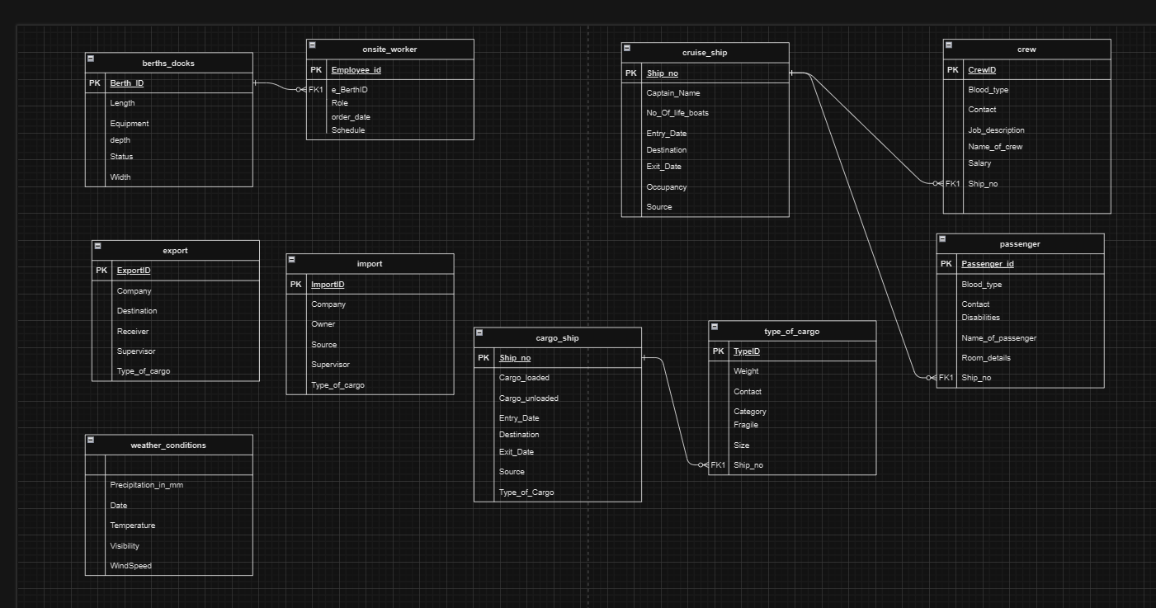

**V. Normalization**

Perform normalization (1NF, 2NF, 3NF, BCNF) as applicable for the entire database.

Altered the tables to add primary keys to all of the tables.

(Done after the queries were run)

For 3nf:

CREATE TABLE Ship_Cargo (

Ship_no INT,

TypeID INT,

PRIMARY KEY (Ship_no, TypeID),

FOREIGN KEY (Ship_no) REFERENCES Cargo_ship(Ship_no),

FOREIGN KEY (TypeID) REFERENCES Type_of_cargo(TypeID)

);

CREATE TABLE Crew_Details (

CrewID INT PRIMARY KEY,

Name_of_crew VARCHAR(255),

Job_description VARCHAR(255),

Contact VARCHAR(255),

Blood_type VARCHAR(255),

FOREIGN KEY (CrewID) REFERENCES Crew(CrewID)

);

CREATE TABLE Passenger_Details (

PassengerID INT PRIMARY KEY,

Name_of_passenger VARCHAR(255),

Contact VARCHAR(255),

Blood_type VARCHAR(255),

Room_details VARCHAR(255),

Disabilities VARCHAR(255),

FOREIGN KEY (PassengerID) REFERENCES Passenger(PassengerID)

);

ALTER TABLE Type_of_cargo DROP COLUMN Ship_no;

ALTER TABLE Crew DROP COLUMN Blood_type;

ALTER TABLE Crew DROP COLUMN Contact;

ALTER TABLE Passenger DROP COLUMN Blood_type;

ALTER TABLE Passenger DROP COLUMN Contact;

ALTER TABLE Passenger DROP COLUMN Room_details;

ALTER TABLE Passenger DROP COLUMN Disabilities;

**VI. SQL Queries**

Using a DBMS software (SQLite3 or MySQL or any other of your choice):

* Create the tables
* Populate the tables (insert some meaningful data, at least 10 tuples for each relation)
* Run SQL queries (minimum 20) covering **all concepts** learned in the class

This section should contain the question, SQL code, and the output snapshot for each query.

* Create:
  + CREATE TABLE Import (

ImportID INT PRIMARY KEY,

Source VARCHAR(255),

Type_of_Cargo VARCHAR(255),

Owner VARCHAR(255),

Supervisor VARCHAR(255),

Company VARCHAR(255)

);

* + CREATE TABLE Export (

ExportID INT PRIMARY KEY,

Destination VARCHAR(255),

Type_of_Cargo VARCHAR(255),

Supervisor VARCHAR(255),

Receiver VARCHAR(255),

Company VARCHAR(255)

);

* + CREATE TABLE Cargo_ship (

Ship_no INT PRIMARY KEY,

Type_of_Cargo VARCHAR(255),

Source VARCHAR(255),

Destination VARCHAR(255),

Cargo_unloaded INT,

Cargo_loaded INT,

Entry_date DATE,

Exit_date DATE

);

* + CREATE TABLE Type_of_cargo (

TypeID INT PRIMARY KEY,

Ship_no INT,

Live VARCHAR(255),

Fragile BOOLEAN,

Size VARCHAR(255),

Weight FLOAT,

FOREIGN KEY (Ship_no) REFERENCES Cargo_ship(Ship_no)

);

* + CREATE TABLE Cruise_ship (

Ship_no INT PRIMARY KEY,

Captain_Name VARCHAR(255),

Source VARCHAR(255),

Destination VARCHAR(255),

Occupancy INT,

No_Of_life_boats INT,

Entry_date DATE,

Exit_date DATE

);

* + CREATE TABLE Crew (

CrewID INT PRIMARY KEY,

Ship_no INT,

Name_of_crew VARCHAR(255),

Job_description VARCHAR(255),

Contact VARCHAR(255),

Blood_type VARCHAR(255),

FOREIGN KEY (Ship_no) REFERENCES Cruise_ship(Ship_no)

);

* + CREATE TABLE Passenger (

PassengerID INT PRIMARY KEY,

Name_of_passenger VARCHAR(255),

Ship_no INT,

Contact VARCHAR(255),

Blood_type VARCHAR(255),

Room_details VARCHAR(255),

Disabilities VARCHAR(255),

FOREIGN KEY (Ship_no) REFERENCES Cruise_ship(Ship_no)

);

* + CREATE TABLE Onsite_worker (

WorkerID INT PRIMARY KEY,

Name VARCHAR(255),

Employee_id INT,

Role VARCHAR(255),

Blood_type VARCHAR(255),

Contact VARCHAR(255),

Schedule VARCHAR(255)

);

* + CREATE TABLE Weather_conditions (

WeatherID INT PRIMARY KEY,

Date DATE,

Temperature FLOAT,

WindSpeed FLOAT,

Visibility VARCHAR(255),

Precipitation VARCHAR(255)

);

* + CREATE TABLE Berths_docks (

BerthID INT PRIMARY KEY,

Length FLOAT,

Width FLOAT,

Status VARCHAR(255),

Depth FLOAT,

Equipment_available VARCHAR(255)

);

* Alter query:
  + [ALTER](http://localhost/phpmyadmin/url.php?url=https://dev.mysql.com/doc/refman/8.0/en/alter-table.html) [TABLE](http://localhost/phpmyadmin/url.php?url=https://dev.mysql.com/doc/refman/8.0/en/alter-table.html) `weather_conditions` CHANGE `Precipitation` `Precipitation_in_mm` INT(255) [NOT](http://localhost/phpmyadmin/url.php?url=https://dev.mysql.com/doc/refman/8.0/en/logical-operators.html%23operator_not) NULL;
  + [ALTER](http://localhost/phpmyadmin/url.php?url=https://dev.mysql.com/doc/refman/8.0/en/alter-table.html) [TABLE](http://localhost/phpmyadmin/url.php?url=https://dev.mysql.com/doc/refman/8.0/en/alter-table.html) `type_of_cargo` CHANGE `Live` `Category`
  + ALTER TABLE `weather_conditions` DROP `WeatherID`;
  + ALTER TABLE `onsite_worker` DROP `WorkerID`;
  + ALTER TABLE `onsite_worker` ADD PRIMARY KEY(`Employee_id`);
  + ALTER TABLE `passenger`DROP `PassengerID`;
  + ALTER TABLE `passenger` ADD `Passenger_id` INT(255) NOT NULL FIRST;
  + Alter Table onsite_worker ADD e_BerthID int(255) not null
  + Alter Table onsite_worker ADD CONSTRAINT e_BerthID FOREIGN KEY(e_BerthID) REFERENCES berths_docks(BerthID)
  + ALTER TABLE `crew` ADD `Salary` INT(255) NOT NULL AFTER `Blood_type`;
  + ALTER TABLE `weather_conditions` ADD PRIMARY KEY(`Date`);
  + ALTER TABLE `passenger` ADD PRIMARY KEY(`Passenger_id`);
* Insert into:
  + INSERT INTO Import (ImportID, Source, Type_of_Cargo, Owner, Supervisor, Company)

VALUES

(1, 'Port A', 'Aquatic', 'ABC Importers', 'John Doe', 'ABC Company'),

(2, 'Port B', 'Plant', 'XYZ Importers', 'Jane Smith', 'XYZ Corporation'),

(3, 'Port C', 'Animal', 'PQR Importers', 'Jack Black', 'PQR Company'),

(4, 'Port D', 'Toys', 'LMN Importers', 'Emma Brown', 'LMN Corporation'),

(5, 'Port E', 'Books', 'RST Importers', 'Tom Green', 'RST Company'),

(6, 'Port F', 'Aquatic', 'UVW Importers', 'Alice Blue', 'UVW Corporation'),

(7, 'Port G', 'Food', 'IJK Importers', 'Sam Red', 'IJK Company'),

(8, 'Port H', 'Toys', 'EFG Importers', 'Mary Yellow', 'EFG Company'),

(9, 'Port I', 'Books', 'HIJ Importers', 'Peter Purple', 'HIJ Corporation'),

(10, 'Port J', 'Electronics', 'KLM Importers', 'Lily Orange', 'KLM Company');

* + INSERT INTO Export (ExportID, Destination, Type_of_Cargo, Supervisor, Receiver, Company)

VALUES

(11, 'Port C', 'Aquatic', 'Jack Black', 'PQR Retail', 'PQR Enterprises'),

(12, 'Port D', 'Plant', 'Emma Brown', 'LMN Supermart', 'LMN Group'),

(13, 'Port E', 'Animal', 'Alice Blue', 'UVW Fashion', 'UVW Industries'),

(14, 'Port F', 'Toys', 'Sam Red', 'IJK Toys', 'IJK Enterprises'),

(15, 'Port G', 'Books', 'Mary Yellow', 'EFG Bookstore', 'EFG Group'),

(16, 'Port H', 'Aquatic', 'Peter Purple', 'HIJ Electronics', 'HIJ Industries'),

(17, 'Port I', 'Food', 'Lily Orange', 'KLM Fashion', 'KLM Enterprises'),

(18, 'Port J', 'Toys', 'John Doe', 'ABC Supermart', 'ABC Group'),

(19, 'Port K', 'Books', 'Jane Smith', 'XYZ Toys', 'XYZ Enterprises'),

(20, 'Port L', 'Electronics', 'Tom Green', 'RST Bookstore', 'RST Group');

* + INSERT INTO Cargo_ship (Ship_no, Type_of_Cargo, Source, Destination, Cargo_unloaded, Cargo_loaded, Entry_date, Exit_date)

VALUES

(21, 'Aquatic', 'Port A', 'Port C', 100, 50, '2024-01-01', '2024-01-15'),

(22, 'Plant', 'Port B', 'Port D', 200, 100, '2024-01-05', '2024-01-20'),

(23, 'Animal', 'Port C', 'Port E', 150, 80, '2024-01-10', '2024-01-25'),

(24, 'Toys', 'Port D', 'Port F', 120, 60, '2024-01-15', '2024-01-30'),

(25, 'Books', 'Port E', 'Port G', 180, 90, '2024-01-20', '2024-02-05'),

(26, 'Aquatic', 'Port F', 'Port H', 220, 110, '2024-01-25', '2024-02-10'),

(27, 'Food', 'Port G', 'Port I', 130, 70, '2024-01-30', '2024-02-15'),

(28, 'Toys', 'Port H', 'Port J', 160, 80, '2024-02-05', '2024-02-20'),

(29, 'Books', 'Port I', 'Port K', 140, 70, '2024-02-10', '2024-02-25'),

(30, 'Electronics', 'Port J', 'Port L', 200, 100, '2024-02-15', '2024-03-01');

* + INSERT INTO Type_of_cargo (TypeID, Ship_no, Category, Fragile, Size, Weight)

VALUES

(31, 21, 'Fish', TRUE, 'Small', 10.5),

(32, 22, 'Flowers', FALSE, 'Large', 25.0),

(33, 23, 'Animals', TRUE, 'Medium', 50.0),

(34, 24, 'Electronics', FALSE, 'Large', 30.0),

(35, 25, 'Books', FALSE, 'Medium', 20.0),

(36, 26, 'Fish', TRUE, 'Large', 15.0),

(37, 27, 'Food', TRUE, 'Medium', 40.0),

(38, 28, 'Toys', FALSE, 'Small', 5.0),

(39, 29, 'Books', FALSE, 'Large', 35.0),

(40, 30, 'Electronics', TRUE, 'Medium', 25.0);

* + INSERT INTO Cruise_ship (Ship_no, Captain_Name, Source, Destination, Occupancy, No_Of_life_boats, Entry_date, Exit_date)

VALUES

(101, 'Captain Jack', 'Port X', 'Port Y', 500, 10, '2024-02-01', '2024-02-15'),

(102, 'Captain Sparrow', 'Port Z', 'Port W', 600, 12, '2024-02-05', '2024-02-20'),

(103, 'Captain Blackbeard', 'Port A', 'Port B', 550, 11, '2024-02-10', '2024-02-25'),

(104, 'Captain Law', 'Port C', 'Port D', 700, 14, '2024-02-15', '2024-03-01'),

(105, 'Captain Kidd', 'Port E', 'Port F', 450, 9, '2024-02-20', '2024-03-05'),

(106, 'Captain Morgan', 'Port G', 'Port H', 800, 16, '2024-02-25', '2024-03-10'),

(107, 'Captain Whitebeard', 'Port I', 'Port J', 600, 12, '2024-03-01', '2024-03-15'),

(108, 'Captain Teach', 'Port K', 'Port L', 750, 15, '2024-03-05', '2024-03-20'),

(109, 'Captain Roger', 'Port M', 'Port N', 500, 10, '2024-03-10', '2024-03-25'),

(110, 'Captain Nami', 'Port O', 'Port P', 650, 13, '2024-03-15', '2024-03-30');

* + INSERT INTO Crew (CrewID, Ship_no, Name_of_crew, Job_description, Contact, Blood_type)

VALUES

(41, 101, 'AA', 'Engineer', '1234567890', 'A+'),

(42, 102, 'AB', 'Chef', '9876543210', 'O-'),

(43, 103, 'BB', 'Navigator', '2345678901', 'B+'),

(44, 104, 'XY', 'Doctor', '3456789012', 'AB-'),

(45, 105, 'ZW', 'Entertainer', '4567890123', 'A-'),

(46, 106, 'OH', 'Security', '5678901234', 'O+'),

(47, 107, 'TH', 'Technician', '6789012345', 'B-'),

(48, 108, 'NJ', 'Housekeeper', '7890123456', 'AB+'),

(49, 109, 'SRK', 'Waiter', '8901234567', 'A-'),

(50, 110, 'AS', 'Bartender', '9012345678', 'O-');

* + INSERT INTO Passenger (Passenger_id, Name_of_passenger, Ship_no, Contact, Blood_type, Room_details, Disabilities)

VALUES

(1, 'A', 101, '2345678901', 'B+', 'Suite A/Deck 1', "None"),

(2, 'B', 102, '3456789012', 'AB-', 'Cabin B/Deck 2', 'Wheelchair'),

(3, 'C', 103, '4567890123', 'A+', 'Suite C/Deck 3', "None"),

(4, 'D', 104, '5678901234', 'O-', 'Cabin D/Deck 4', 'Crutches'),

(5, 'E', 105, '6789012345', 'B-', 'Suite E/Deck 5', "None"),

(6, 'F', 106, '7890123456', 'AB+', 'Cabin F/Deck 6', 'Wheelchair'),

(7, 'G', 107, '8901234567', 'A-', 'Suite G/Deck 7', "None"),

(8, 'H', 108, '9012345678', 'O+', 'Cabin H/Deck 8', 'Crutches'),

(9, 'I', 109, '0123456789', 'AB-', 'Suite I/Deck 9', "None"),

(10, 'J', 110, '1234567890', 'B+', 'Cabin J/Deck 10', 'Wheelchair');

* + INSERT INTO Onsite_worker (Name, Employee_id, Role, Blood_type, Contact, Schedule, e_BerthID)

VALUES

('A', 1001, 'Supervisor', 'A-', '4567890123', 'Mon-Fri, 9am-5pm', 51),

('B', 1002, 'Worker', 'O+', '5678901234', 'Tue-Sat, 10am-6pm', 52),

('C', 1003, 'Technician', 'B+', '6789012345', 'Mon-Fri, 8am-4pm', 53),

('D', 1004, 'Security', 'AB-', '7890123456', 'Wed-Sun, 11pm-7am', 54),

('E', 1005, 'Engineer', 'A+', '8901234567', 'Thu-Mon, 7am-3pm', 55),

('F', 1006, 'Doctor', 'O-', '9012345678', 'Fri-Tue, 12pm-8pm', 56),

('G', 1007, 'Nurse', 'B-', '0123456789', 'Sat-Wed, 3pm-11pm', 57),

('H', 1008, 'Housekeeper', 'AB+', '1234567890', 'Sun-Thu, 10am-6pm', 58),

('I', 1009, 'Waiter', 'A-', '2345678901', 'Mon-Fri, 6am-2pm', 59),

('J', 1010, 'Bartender', 'O+', '3456789012', 'Tue-Sat, 4pm-12am', 60);

* + INSERT INTO Weather_conditions (Date, Temperature, WindSpeed, Visibility, Precipitation_in_mm)

VALUES

('2024-01-01', 25.5, 10.2, 'Clear', 1),

('2024-01-02', 24.8, 9.5, 'Clear', 5),

('2024-01-03', 26.0, 11.0, 'Clear', 10),

('2024-01-04', 24.6, 9.8, 'Clear', 18),

('2024-01-05', 25.2, 10.5, 'Clear', 67),

('2024-01-06', 24.9, 9.7, 'Clear', 70),

('2024-01-07', 25.3, 10.1, 'Clear', 86),

('2024-01-08', 25.7, 10.3, 'Clear', 53),

('2024-01-09', 25.1, 9.9, 'Clear', 23),

('2024-01-10', 24.5, 9.6, 'Clear', 0);

* + INSERT INTO Berths_docks (BerthID, Length, Width, Status, Depth, Equipment_available)

VALUES

(51, 100.5, 20.5, 'Occupied', 10.0, 'Cranes'),

(52, 120.0, 25.0, 'Available', 12.0, 'Forklifts'),

(53, 110.0, 22.0, 'Occupied', 11.0, 'Cranes'),

(54, 130.0, 26.0, 'Available', 13.0, 'Forklifts'),

(55, 105.0, 21.0, 'Occupied', 10.5, 'Cranes'),

(56, 115.0, 23.0, 'Available', 11.5, 'Forklifts'),

(57, 125.0, 25.0, 'Occupied', 12.5, 'Cranes'),

(58, 135.0, 27.0, 'Available', 13.5, 'Forklifts'),

(59, 95.0, 19.0, 'Occupied', 9.5, 'Cranes'),

(60, 105.0, 21.0, 'Available', 10.5, 'Forklifts');

* Select:
  + SELECT * FROM cargo_ship;
  + SELECT Ship_no FROM cargo_ship;
  + SELECT COUNT(*) as no_of_ships FROM `cargo_ship`;
  + SELECT * FROM `cargo_ship` WHERE Type_of_Cargo = 'Aquatic';
  + SELECT * FROM `cargo_ship` WHERE Type_of_Cargo = 'Aquatic' AND Ship_no=21;
  + SELECT * FROM `cargo_ship` WHERE Type_of_Cargo LIKE '%c';
* Order by:
  + SELECT * FROM `weather_conditions` ORDER BY Date DESC;
  + SELECT * FROM `cargo_ship` ORDER BY Entry_date ASC;
* Update:
  + UPDATE weather_conditions set Precipitation_in_mm = Precipitation_in_mm*1.05
  + UPDATE weather_conditions set Precipitation_in_mm = Precipitation_in_mm + 2 where Precipitation_in_mm<=0
  + UPDATE weather_conditions
  + set Precipitation_in_mm = Precipitation_in_mm - 2
  + where Precipitation_in_mm < (SELECT AVG(Temperature) FROM weather_conditions)
* Join
  + SELECT * from cruise_ship NATURAL JOIN passenger;
  + SELECT ow.Name, ow.Role, bd.status FROM onsite_worker AS ow INNER JOIN berths_docks AS bd ON ow.e_BerthID = bd.BerthID;
  + SELECT * from import INNER JOIN export on import.Source = export.Destination;
  + SELECT * from import LEFT OUTER JOIN export on import.Source = export.Destination;
  + SELECT * from import RIGHT OUTER JOIN export on import.Source = export.Destination;
* Update:
  + UPDATE `crew` SET `Salary` = '55' WHERE `crew`.`CrewID` = 41
  + UPDATE `crew` SET `Salary` = '60' WHERE `crew`.`CrewID` = 42
  + UPDATE `crew` SET `Salary` = '62' WHERE `crew`.`CrewID` = 43
  + UPDATE `crew` SET `Salary` = '65' WHERE `crew`.`CrewID` = 44
  + UPDATE `crew` SET `Salary` = '77' WHERE `crew`.`CrewID` = 45
  + UPDATE `crew` SET `Salary` = '80' WHERE `crew`.`CrewID` = 46
  + UPDATE `crew` SET `Salary` = '84' WHERE `crew`.`CrewID` = 47
  + UPDATE `crew` SET `Salary` = '87' WHERE `crew`.`CrewID` = 48
  + UPDATE `crew` SET `Salary` = '90' WHERE `crew`.`CrewID` = 49
  + UPDATE `crew` SET `Salary` = '95' WHERE `crew`.`CrewID` = 50
* Aggregate
  + SELECT AVG(Salary) FROM `crew`;
  + SELECT MAX(Salary) FROM `crew`;
  + SELECT MIN(Salary) FROM `crew`;
  + SELECT COUNT(Salary) FROM `crew` WHERE salary>60;
* Views:
  + CREATE VIEW expimp AS SELECT e.Destination, i.source, i.Type_of_Cargo from export as e, import as i WHERE i.Type_of_cargo = 'Aquatic';

**VI. Project demonstration**

* Tools/software/ libraries used
* Screenshot and Description of the Demonstration of project ( If GUI is made)

We used phpMyAdmin to make and perform operations on the database.

Output:

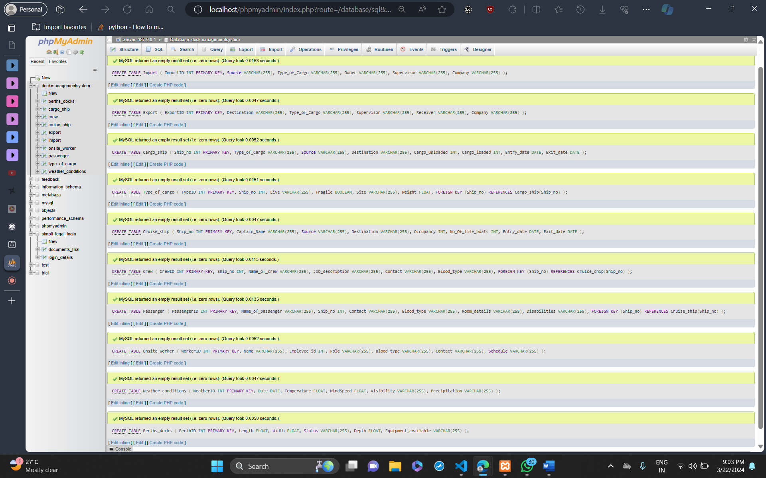

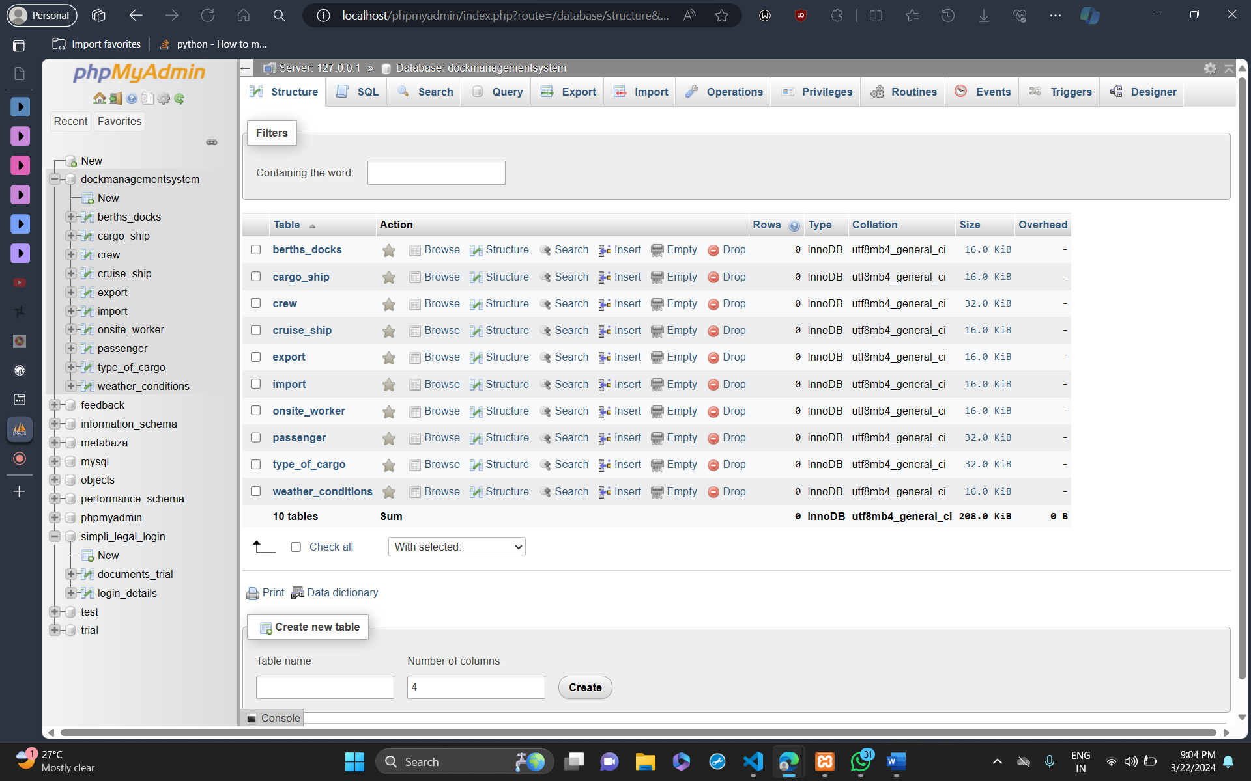

Select:

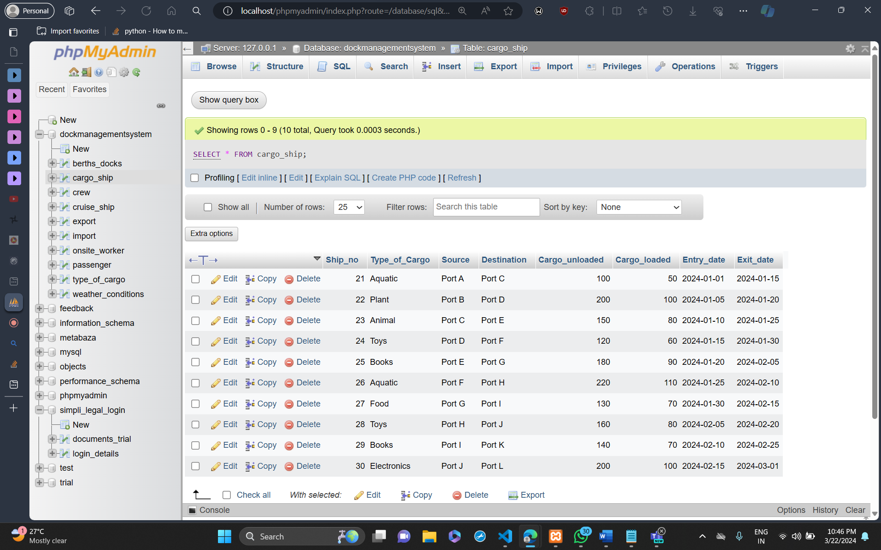

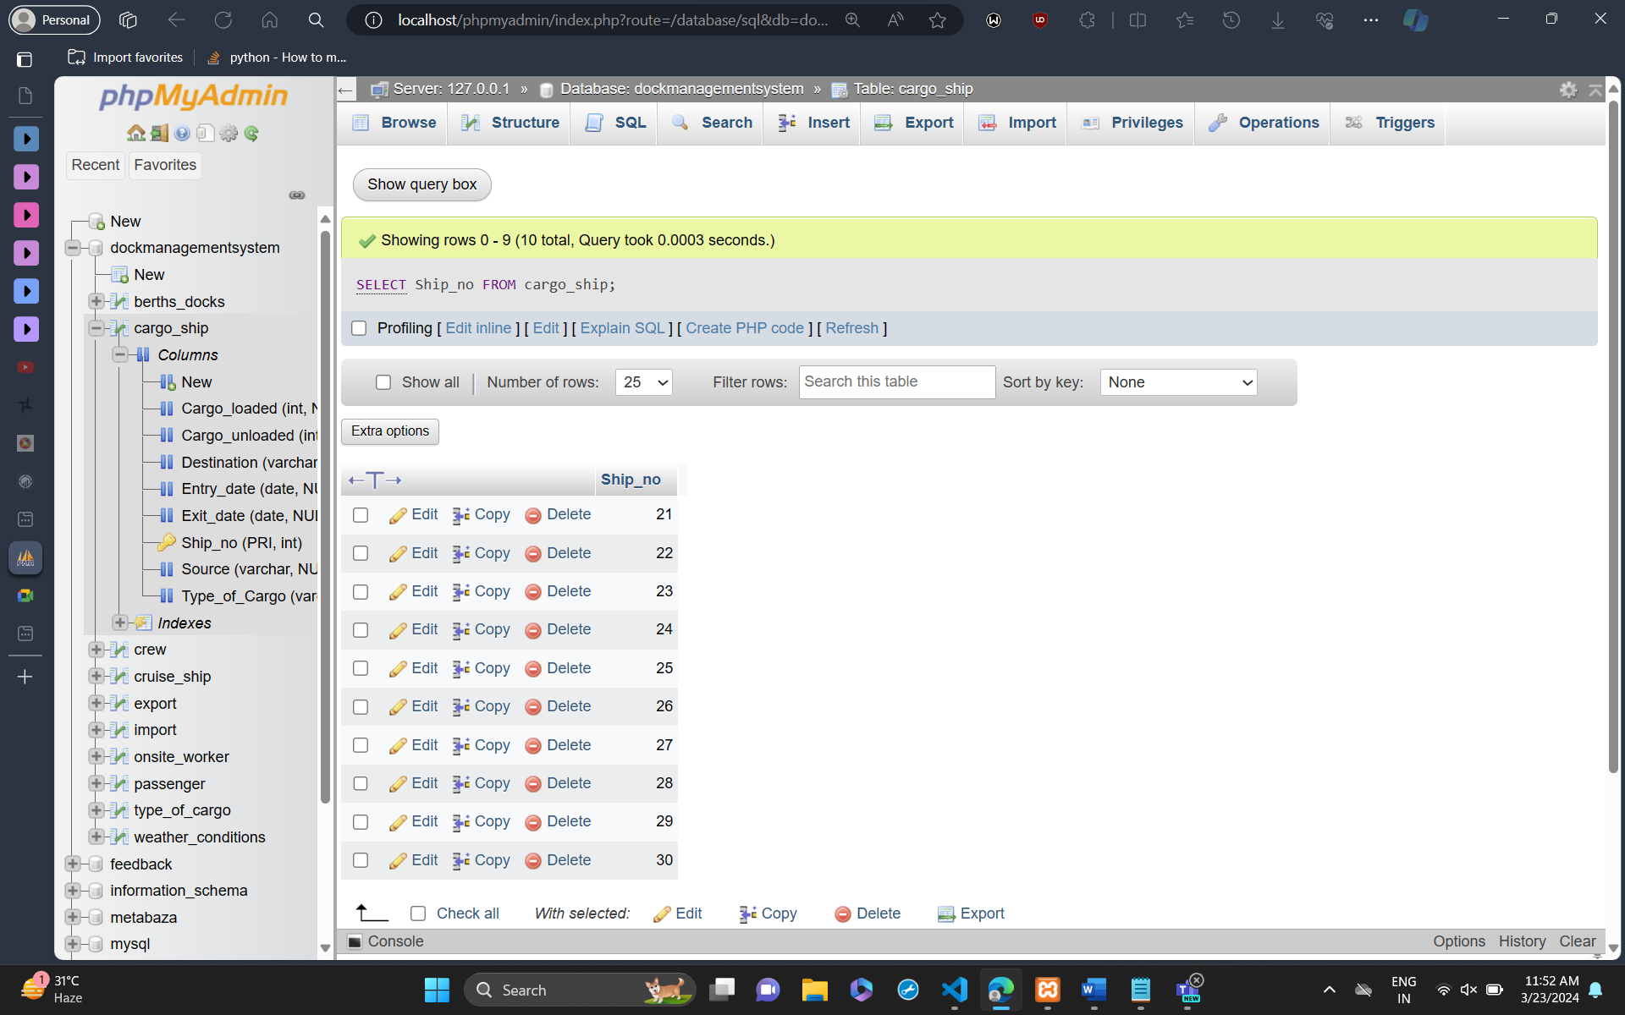

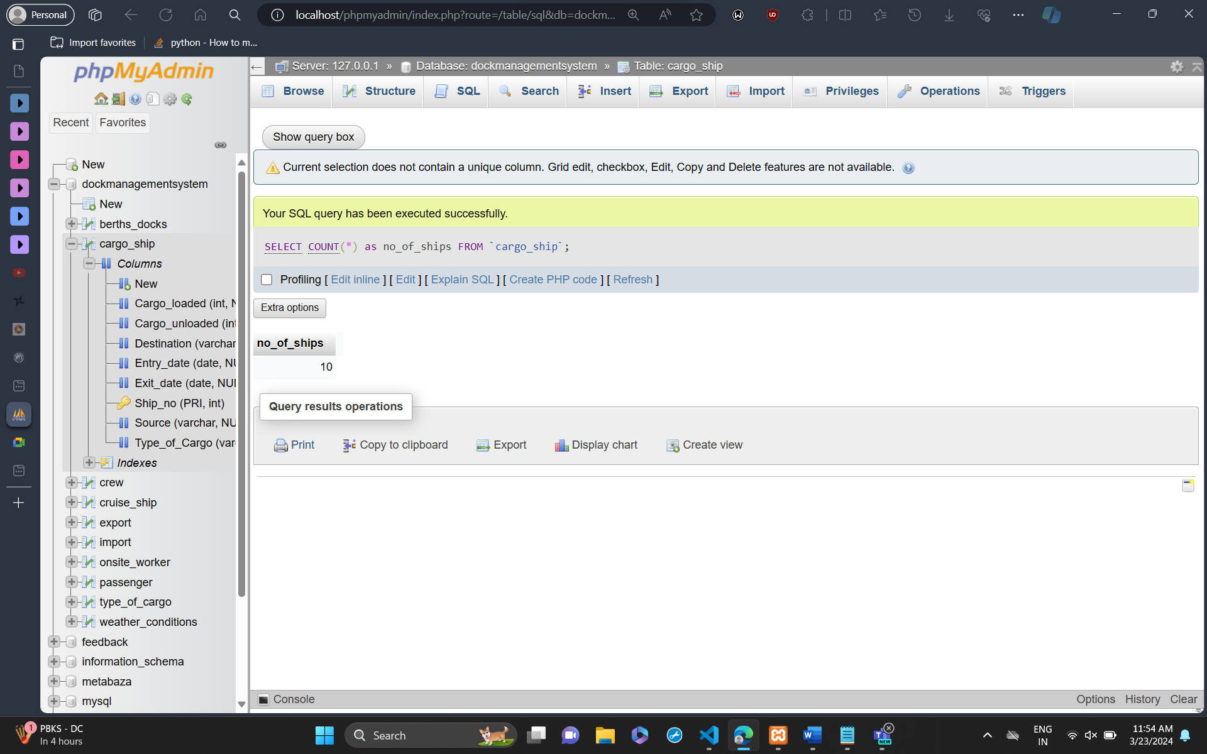

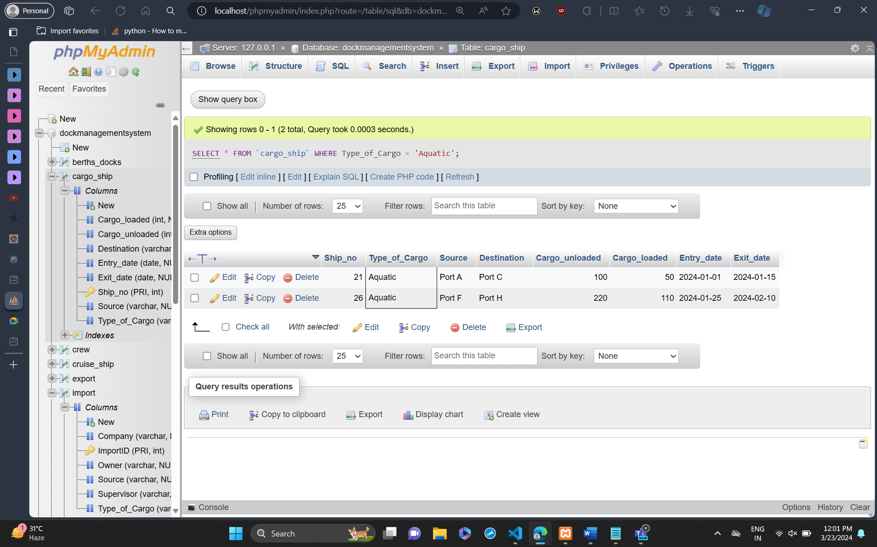

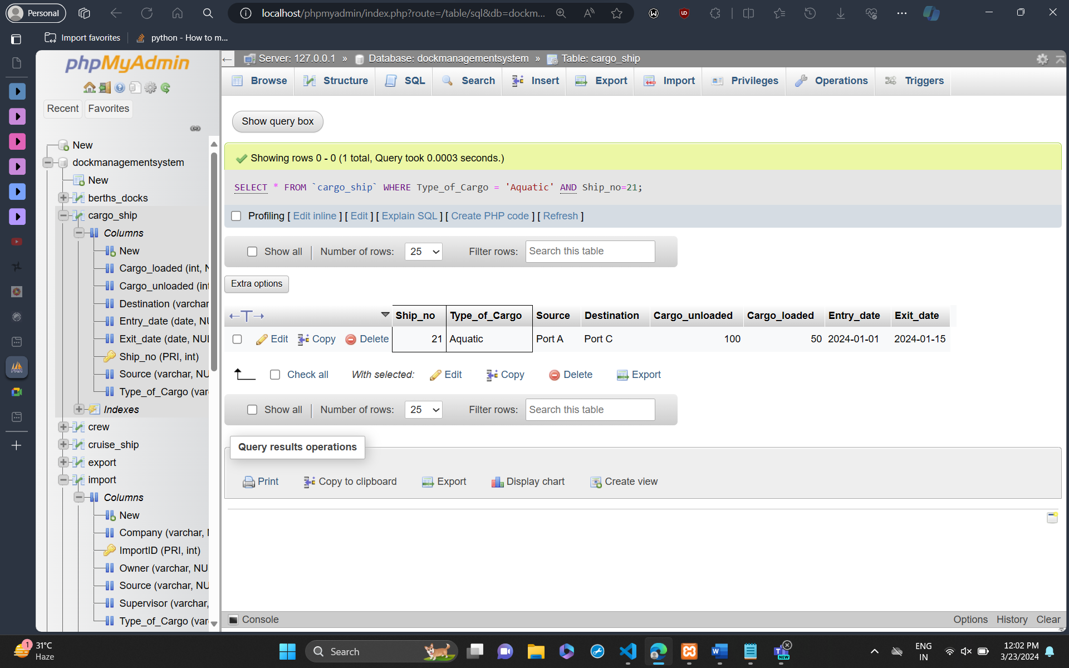

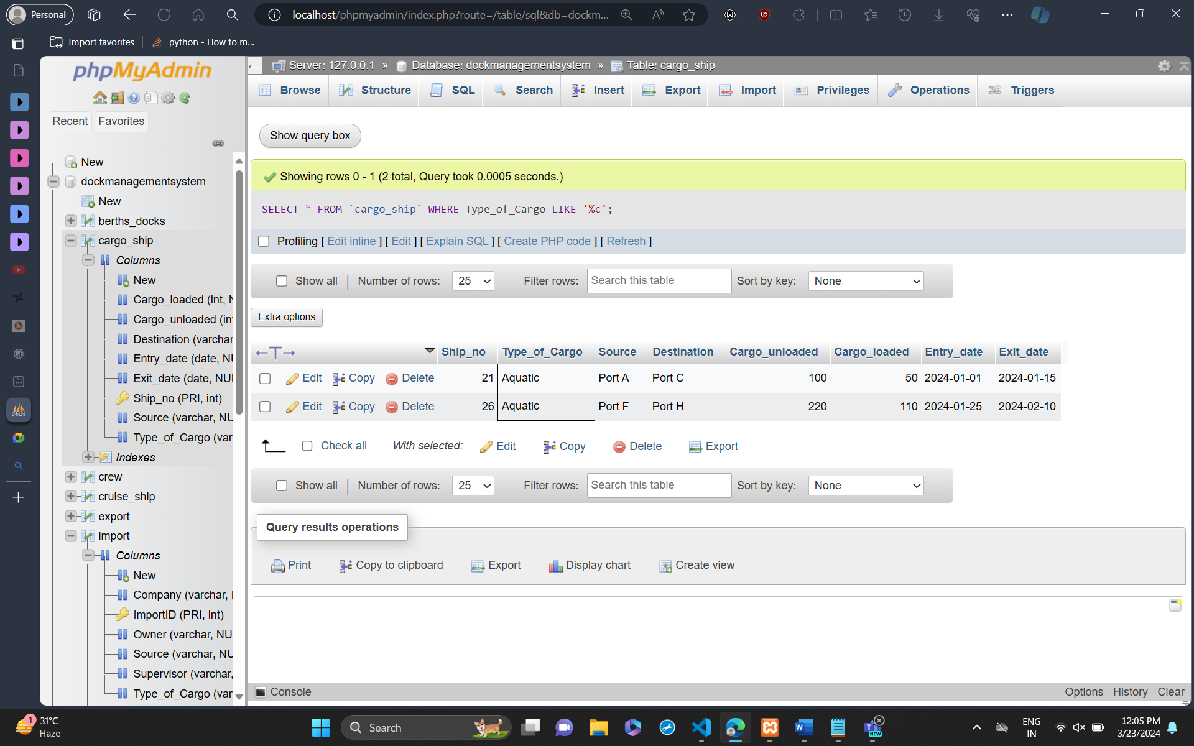

Order by:

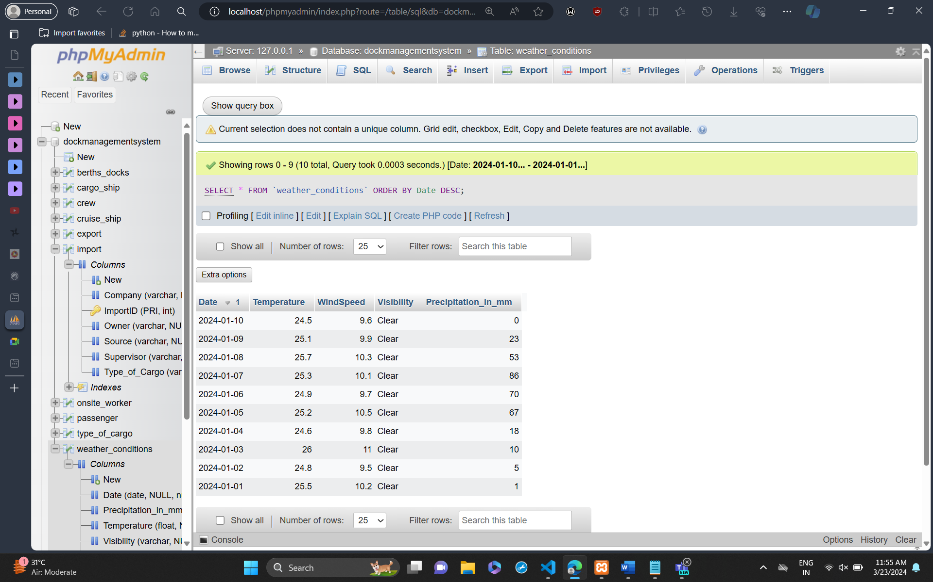

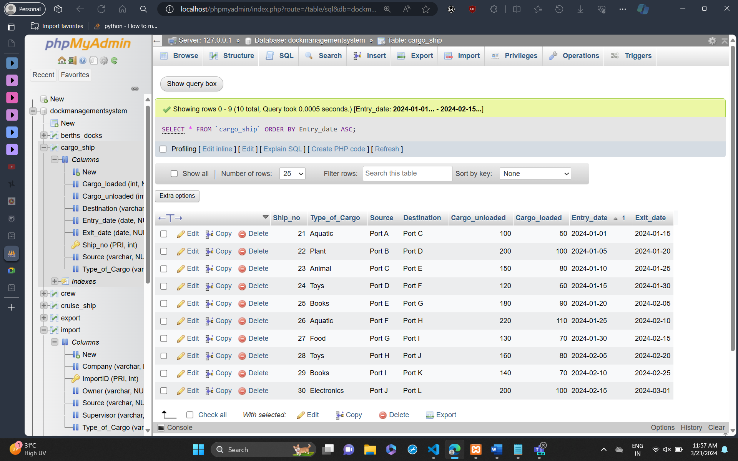

Update:

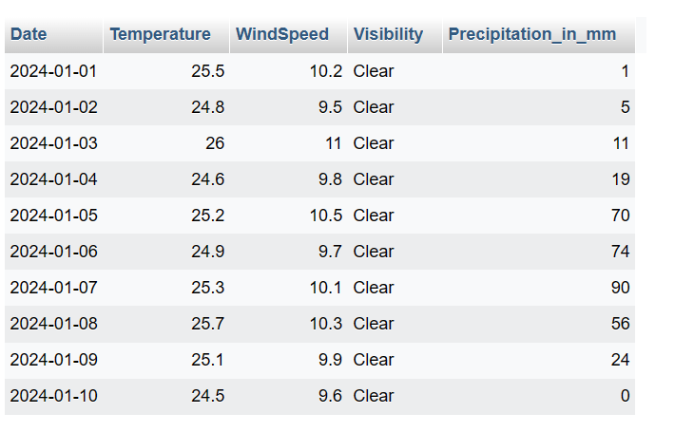

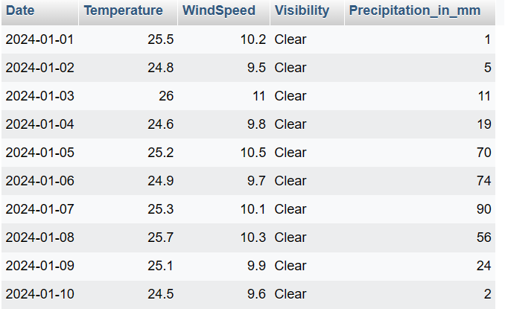

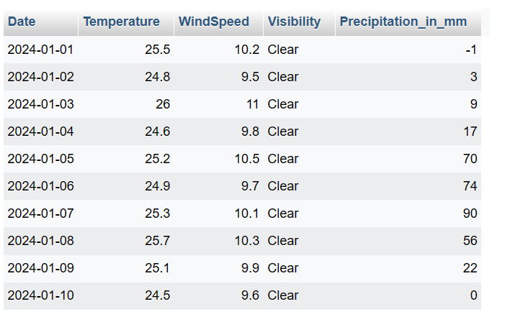

Joins:

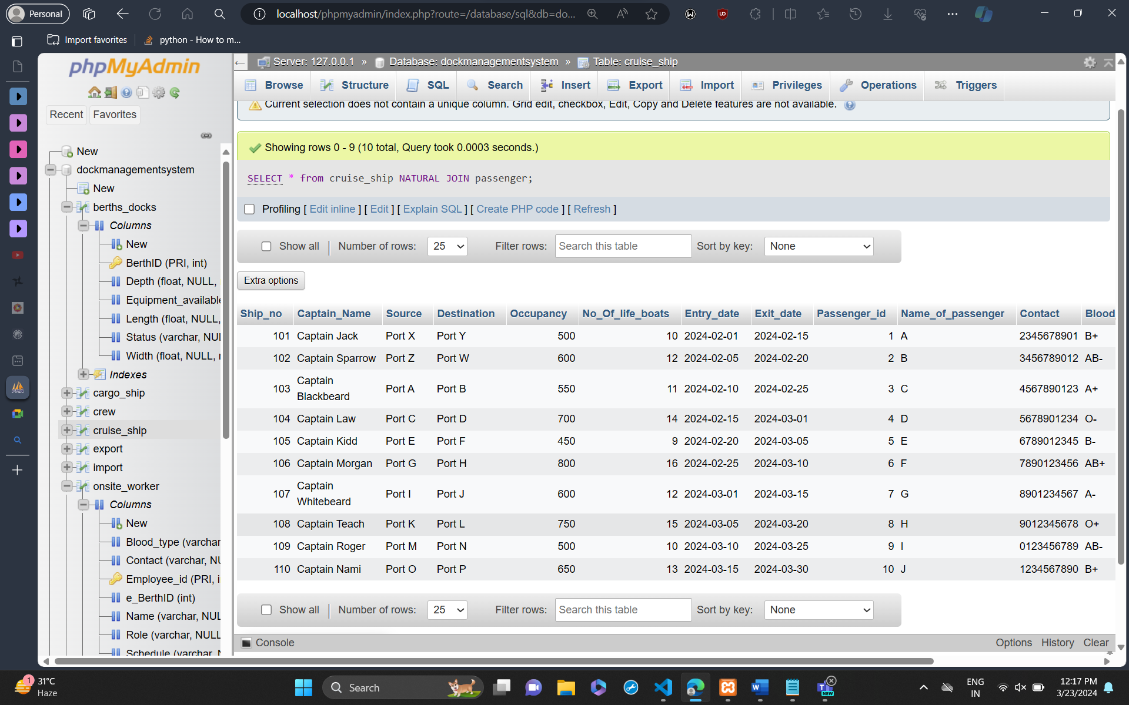

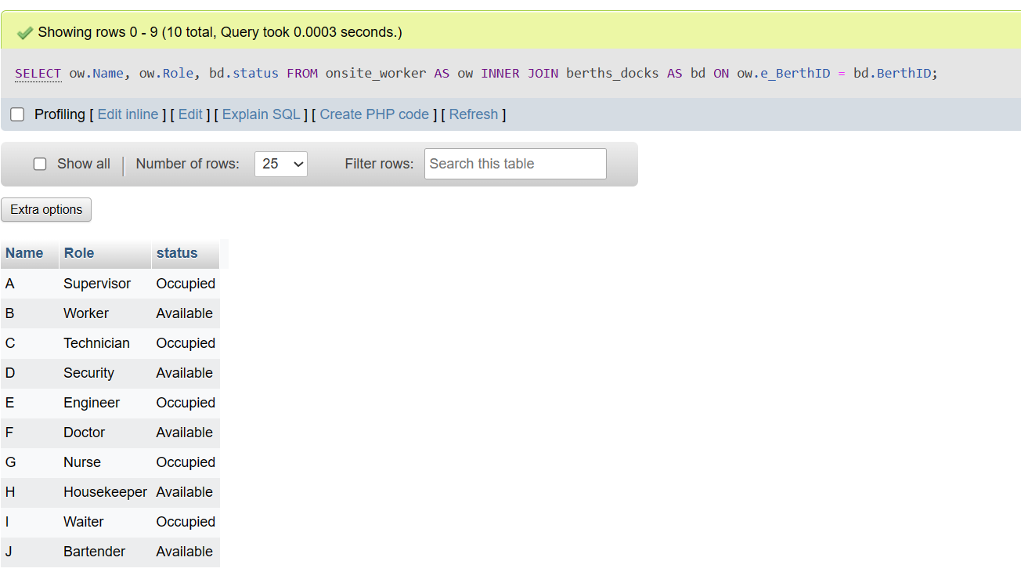

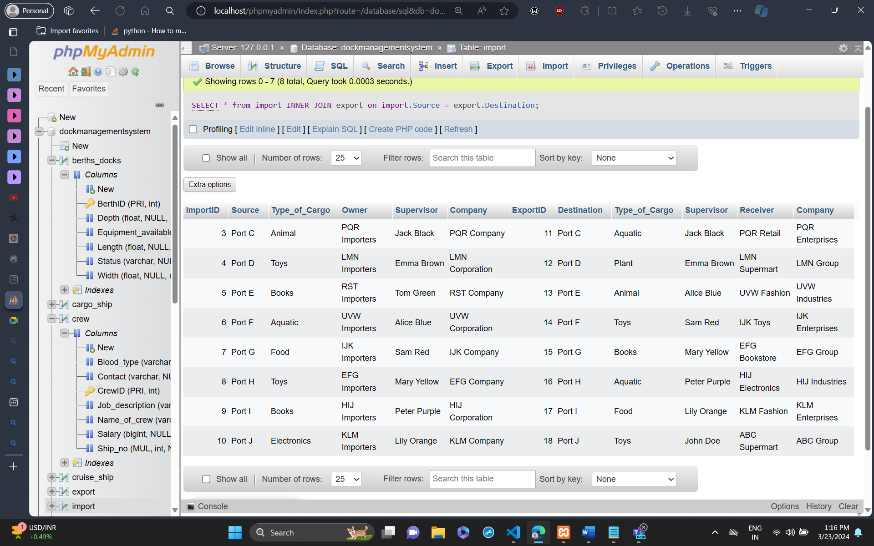

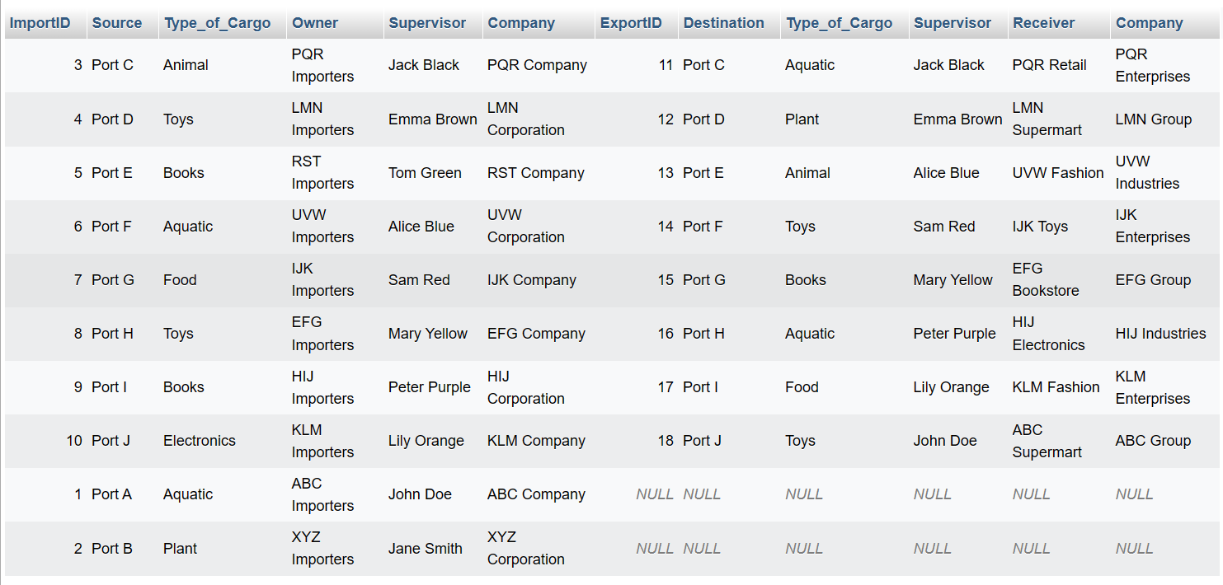

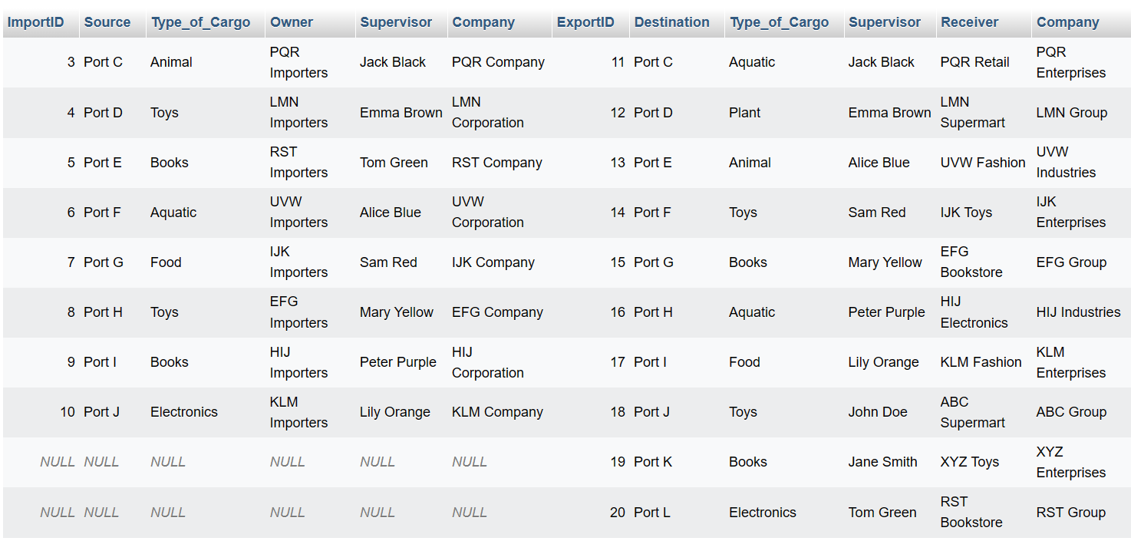

Update:

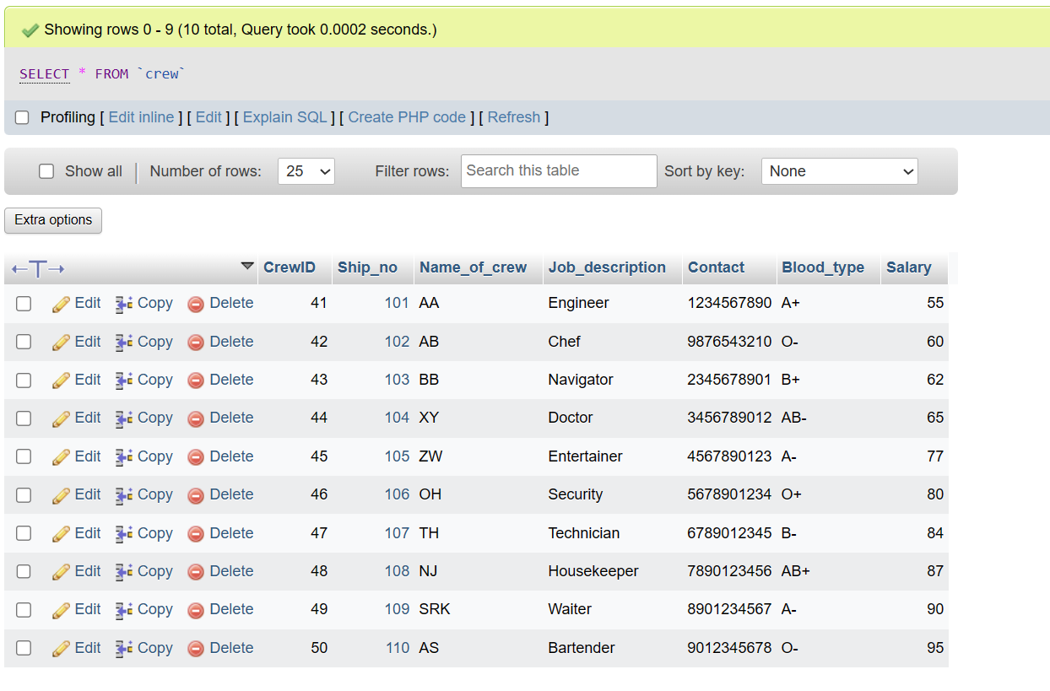

Aggregate:

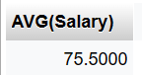

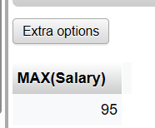

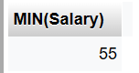

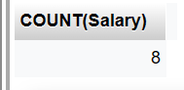

Views:

Select * from expimp;

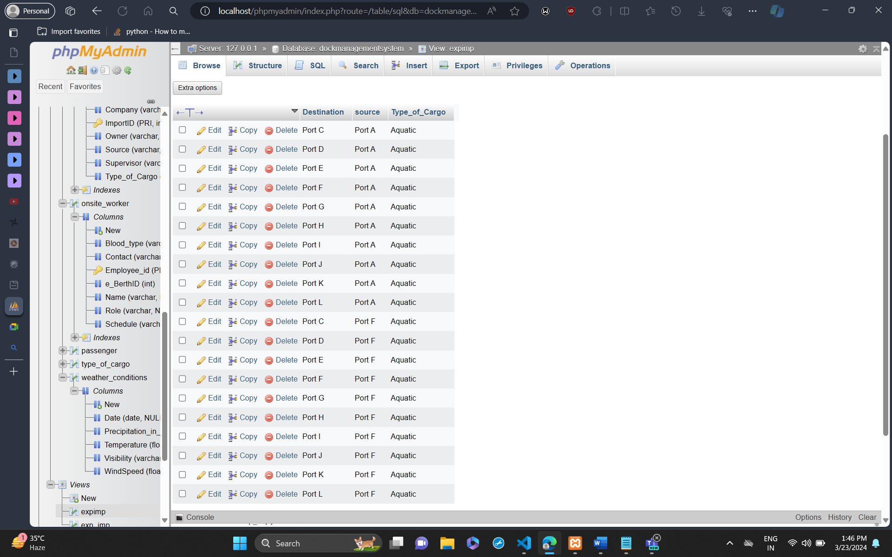

**VII. Self -Learning beyond classroom**

:

* What new aspects did you learn on your own ? You have to mention learning beyond the classroom

We understood the real-life applications of SQL by performing hands on a project while learning about the real world and how everything uses database to make sure that the work process proceeds without any interruptions. Based on our topic we could see that the world of harbor management may seem simple, but the amount of data variables like details of a specific ship grows as our research continues.

**VIII. Learning from the Project**

Include learning from the project:

* How this project helped you?

I learnt how to use SQL commands to get the required outputs. I also learnt and overcame the various challenges that I came across while making the database. Topics like views and normalization were something new which we hadn’t learnt before and thus felt like we were improving our basic knowledge on this subject.

**IX. Challenges Faced**

The challenges we faced was figuring out how to normalize the database. Choosing what primary key for each table was also difficult.

**X. Conclusion**

* What are the key takeaways from the project?

After completing this SQL project, I've gained a solid understanding of database management and querying. Working with various tables, relationships, and queries has improved my skills in data manipulation and retrieval. I've learned how to design and implement a database schema effectively, ensuring data integrity and consistency. This project has been a valuable learning experience, providing hands-on practice and enhancing my SQL proficiency.